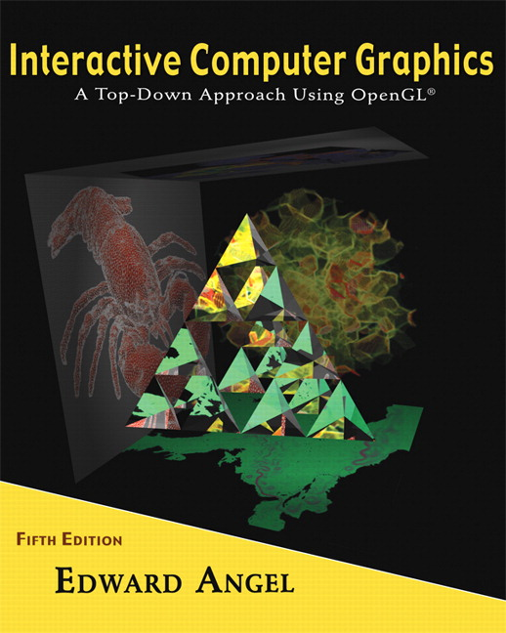

Name: ______________________ Term # ____
Programming Assignment 2
(100 points)

The Programming Assignment is to be turned in the first ten minutes of the due date class as:

Hardcopy (with your terminal #!)
Source Code and screenshots that shows that your Visual Studio 2008 “Programming Assignment 2” PROJECT compiles and runs!

Electronic: Submit the Visual Studio2008 “Programming Assignment 2” zipped PROJECT to BB so you can run it in 200 PGH!

“HOUSE - Summer 2010” Modeling Instructions
(The file “House Summer 2010.pdf” contains the specifications for the house that you will bet modeling.)

1. The glutCreateWindow OpenGL call will take as parameter “YourLastName House Version 2”.
2. Start with the LowerHouse.c that you have created in Programming Assignment 1 and call the file MyHouse.c.

3. Complete the “to scale” parts of the “HOUSE - Summer 2010”:

- the “window unit” created in Programming Assignment 1 needs to be used by transformations such as rotations and translations to create all the other window units. (Windows).
- the “roof” (front, side, back) needs to be created.

(Basically the whole house needs to be created!)

4. Create a menu or keyboard (f, b, r, l, t, u, i) that allows that you to view the house from:

- front;
- back;
- right side;
- left side;
- top;
- under;
- isometric.

Get a screenshot of the “YourLastName House Version 2” window for each view.

